|  |  |
| --- | --- |
| **Article ID:** | 2055 |
| **Article Name:** | [2055]The top heating element of my oven is not warming up |
| **Topic Location:** | Cooking/Oven/Usage/Performance |
| **Meta-data:** | heating element, top, not working, not heating |
| **Related Articles:** |  |
| **Related Questions:** |  |

PNC

DIY

Safety

Link

Email

Book Engineer

Multimedia

Brand

**Article Content:**

First of all, check if you are using a cooking function that activates the top heating element. Please refer to the instruction manual.

Also be aware that some ovens have a double top heating element. When using a cooking function with top heating only the outer part of the top heating element (A) will warm up. The inner part (B) of the heating element corresponds to the grill function.

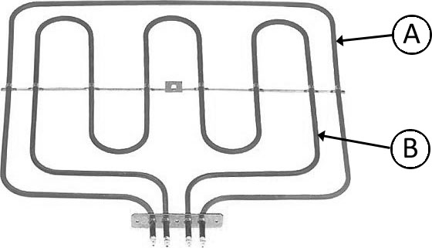

[http://www.ezone-teams.electrolux.com/knowledgeteamcustcareemea/Authoring/Multimedia%20Files/Images/Pictures/Cooking/[2055]%20Oven%20Top%20Heating%20Element.jpg](http://www.ezone-teams.electrolux.com/knowledgeteamcustcareemea/Authoring/Multimedia%20Files/Images/Pictures/Cooking/%5b2055%5d%20Oven%20Top%20Heating%20Element.jpg)

If after considering this, you still find that the top heating element still doesn’t warm up, you should get in contact with our service force clicking in the link below.

``Book_eng_Macro